Quiz 1 20/2/2020

In the Hypothetical Machine the contents of memory was as shown. And PC contents is 300. Show the contents of memory and PC , AC , IR after execute three instructions (three fetch cycle and there execute cycle)

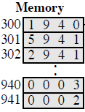

**Solution:**

**Ram: cpu:**

|  |  |  |  |  |
| --- | --- | --- | --- | --- |
| **300** | **1** | **9** | **4** | **0** |
| *301* | ***5*** | ***9*** | ***4*** | ***1*** |
| 302 | **2** | **9** | **4** | **1** |

|  |  |  |  |  |
| --- | --- | --- | --- | --- |
| 3 | 0 | 0 |  | pc |
|  |  |  |  | ac |
| 1 | 9 | 4 | 0 | ir |

|  |  |  |  |  |
| --- | --- | --- | --- | --- |
| 940 | 0 | 0 | 0 | 3 |
| 941 | 0 | 0 | 0 | 2 |

|  |  |  |  |  |
| --- | --- | --- | --- | --- |
| **300** | **1** | **9** | **4** | **0** |
| 301 | **5** | **9** | **4** | **1** |
| 302 | **2** | **9** | **4** | **1** |

|  |  |  |  |  |
| --- | --- | --- | --- | --- |
| 3 | 0 | 1 |  | pc |
| 0 | 0 | 0 | 3 | ac |
| 1 | 9 | 4 | 0 | ir |

|  |  |  |  |  |
| --- | --- | --- | --- | --- |
| 940 | 0 | 0 | 0 | 3 |
| 941 | 0 | 0 | 0 | 2 |

=================================

Ram : cpu:

|  |  |  |  |  |
| --- | --- | --- | --- | --- |
| **300** | **1** | **9** | **4** | **0** |
| 301 | **5** | **9** | **4** | **1** |
| 302 | **2** | **9** | **4** | **1** |

|  |  |  |  |  |
| --- | --- | --- | --- | --- |
| 3 | 0 | 1 |  | pc |
| 0 | 0 | 3 |  | ac |
| 5 | 9 | 4 | 1 | ir |

|  |  |  |  |  |
| --- | --- | --- | --- | --- |
| 940 | 0 | 0 | 0 | 3 |
| 941 | 0 | 0 | 0 | 2 |

|  |  |  |  |  |
| --- | --- | --- | --- | --- |
| **300** | **1** | **9** | **4** | **0** |
| 301 | **5** | **9** | **4** | **1** |
| 302 | **2** | **9** | **4** | **1** |

|  |  |  |  |  |
| --- | --- | --- | --- | --- |
| 3 | 0 | 2 |  | pc |
| 0 | 0 | 5 |  | ac |
| 5 | 9 | 4 | 1 | ir |

|  |  |  |  |  |
| --- | --- | --- | --- | --- |
| 940 | 0 | 0 | 0 | 3 |
| 941 | 0 | 0 | 0 | 2 |

3+2=5

===============================

Ram: cpu:

|  |  |  |  |  |
| --- | --- | --- | --- | --- |
| **300** | **1** | **9** | **4** | **0** |
| 301 | **5** | **9** | **4** | **1** |
| 302 | **2** | **9** | **4** | **1** |

|  |  |  |  |  |
| --- | --- | --- | --- | --- |
| 3 | 0 | 2 |  | pc |
| 0 | 0 | 0 | 5 | ac |
| 2 | 9 | 4 | 1 | ir |

|  |  |  |  |  |
| --- | --- | --- | --- | --- |
| 940 | 0 | 0 | 0 | 3 |
| 941 | 0 | 0 | 0 | 2 |

|  |  |  |  |  |
| --- | --- | --- | --- | --- |
| **300** | **1** | **9** | **4** | **0** |
| 301 | **5** | **9** | **4** | **1** |
| 302 | **2** | **9** | **4** | **1** |

|  |  |  |  |  |
| --- | --- | --- | --- | --- |
| 3 | 0 | 3 |  | pc |
| 0 | 0 | 0 | 5 | ac |
| 2 | 9 | 4 | 1 | ir |

|  |  |  |  |  |
| --- | --- | --- | --- | --- |
| 940 | 0 | 0 | 0 | 3 |
| 941 | 0 | 0 | 0 | 5 |

**Show the contents of PC , AC and IR and memory after the execution of each instruction of the following program on the Hypothetical Machine:**

**300 LOAD 550**

**301 ADD 551**

**302 STORE 600**

**Where the contents of memory at 550 is 3 and at 551 is 4.**

**Solution:**

**“1”**

**Fetch:**

**Ac:000 ir:1550 pc:300**

**550:0003 551:0004 600:0000**

**Execution:**

**Ac:0003 ir:1550 pc:300**

**550:0003 551:0004 600:0000**

**“2”**

**Fetch:**

**Ac:0003 ir:5551 pc:301**

**550:0003 551:0004 600:0000**

**Execution:**

**Ac:0007 ir:5551 pc:301**

**550:0003 551:0004 600:0000**

**“3”**

**Fetch:**

**Ac:0007 ir:2600 pc:302**

**550:0003 551:0004 600:0000**

**Execution:**

**Ac:0000 ir:2600 pc:302**

**550:0003 551:0004 600:0007**

**The following figure provide the main characteristics of Hypothetical Machine.**

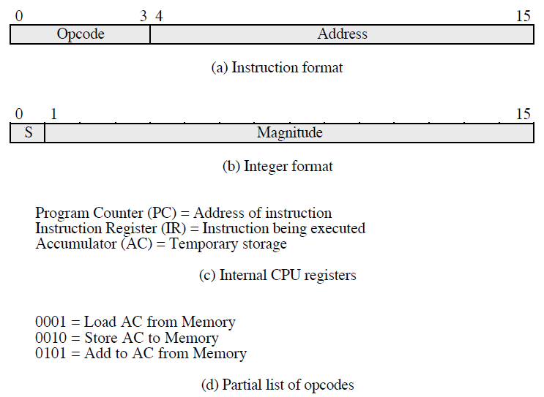

**The hypothetical machine also has two I/O instructions:**

**0011 = load AC from I/O**

**0111 =store AC to I/O**

**In these case, the 12-bi address identifies a particular I/O device. Show the program execution for the following program:**

**1. Load AC from device 5.**

**2. Add contents of memory location 940.**

**3. Store AC to device 6.**

**Assume that the next value retrieved from device 5 is 3 and that location 940 contains a value of 2.**

**Solution:**

**Ram:**

|  |  |
| --- | --- |
| **3005** | **300** |
| **5940** | **301** |
| **7006** | **302** |

**after execute the three instructions:**

**device 5 :0003**

**940: 2**

**Device 6: 0005**